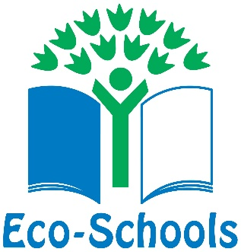

We are thrilled to have finally received our Green Flag from “Keep Britain Tidy”. We have also received our certificate and a fantastic letter.
Karyn Fullerton from Keep Britain Tidy wrote” I would like to congratulate you for all the time and effort that has been invested in environmental education at your school. Your award is well deserved and reflects the hard work you have put into the programme”.
The assessor Francis Hyland who visited our school commented “It was a privilege to assess your school and I could see how hard Mrs McIver and her various Eco Committees have been working on environmental issues for many years. I was overwhelmed by the sheer amount of actions that have been completed and was particularly impressed by how Mrs McIver, the committee and Ursuline had strived to involve the whole school and its community. A massive thank you for an inspirational visit and a further thanks for litter picking on one of the best beaches in England, improving thousands of visitor’s experiences.”
The Eco schools programme is an international scheme. In the U.K. there are 19,863 schools registered with the programme and we are now one of the 1,207 who have achieved Green Flag Status.
The next step is to purchase a flagpole, then we will have an official ceremony when we will hoist our Eco Schools Green flag for the first time.
Mrs McIver would also like to thank all her amazing past and present Eco Warriors. Plus, everyone in our Ursuline family from our children, our staff, our fabulous PTFA and supportive parents. She would also like to thank our local community including, Anne-Marie Clegg from Sefton Council, Friends of Crosby beach and Green Sefton.

